Run a command on start and get access to container’s terminal
Below docker compose file will run a specified command when container starts (starts a bash session in this case):
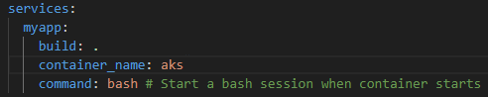

Get access to the container’s terminal
Below docker compose file will allocate a pseudo TTY. It will make it possible to get access to the container’s terminal:
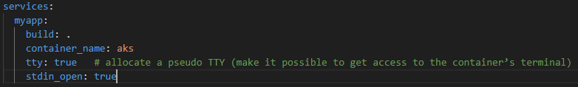
After we run such a container we can get access to its terminal by running this command:
- docker exec -it <container -name> bash

Mount a folder
We can mount a folder to a container so whenever we make change in this folder on the host, the same changes are reflected in the container.
It also works the other way around – changes made in the container are reflected on the host.
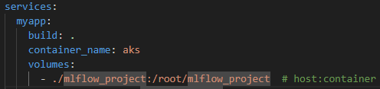

Run container in a background
Docker compose up -d

